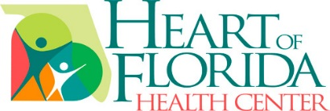
203 E. Silver Springs Blvd., Ste. 101
Ocala, FL 34470
(352)732-6599

LOCATIONS:
Central
1025 SW 1st Avenue
Ocala, FL 34471

East
1801 SE 32nd Avenue
Ocala, FL 34471

Dunnellon
19204 E. Pennsylvania Avenue
Dunnellon, FL 34432

Reddick
4500 NEW 152nd Avenue
Ocala, FL 32686

Belleview
7055 SE 110th Street Road
Belleview, FL 34420

Southwest
100 Marion Oaks Blvd
Ocala, FL 34473

Ocala West
6041 SW 54th St., Ste.100
Ocala, FL 34474

Dear Volunteer Applicant,
Thank you for your interest in the Heart of Florida Health Center volunteer program. We are continuously looking for enthusiastic and motivated volunteers to work in areas such as Reception, Clerical, Computer Work and Health Fair Marketing.
In order to qualify for the program, volunteers must:
- Commit to at least 4 hours per week
- Complete and return volunteer application
- Agree and pass a Level 1 background check
If you wish to be considered for the program, please complete the attached application and return it to the Outreach Associate at the Heart of Florida Health Center.
203 E. Silver Springs Blvd., Ste. 101
Ocala, FL 34470
Attn: Outreach Associate

Once your completed application has been received, we will schedule an interview, conduct a background check, contact your references, and contact you to confirm your welcome meeting.
We look forward to welcoming you into our Heart of Florida family of volunteers. Please contact our office should you have any questions or requests:
Heart of Florida Health Center (352) 877.7177
Sincerely,

Malory Hunter
Outreach Associate
The Heart of Florida Health Center

